Ideation Phase
Brainstorm & Idea Prioritization Template

Date | January 2026
Team ID | LTVIP2026TMIDS47701
Project Name | Visualization tool for electric vehicle charge & Range Analysis.
Maximum Marks | 4 Marks

Brainstorm & Idea Prioritization Template:
Brainstorming provides a free and open environment that encourages everyone within a team to participate in the creative problem-solving process. Prioritization helps in selecting the most impactful and feasible ideas. This approach encourages collaboration, innovation, and structured decision-making to arrive at effective solutions.
This template is used to generate, analyze, and prioritize ideas for building a visualization tool that helps understand electric vehicle charging and range performance using data analytics and dashboards.

Step-1: Team Gathering, Collaboration and Select the Problem Statement
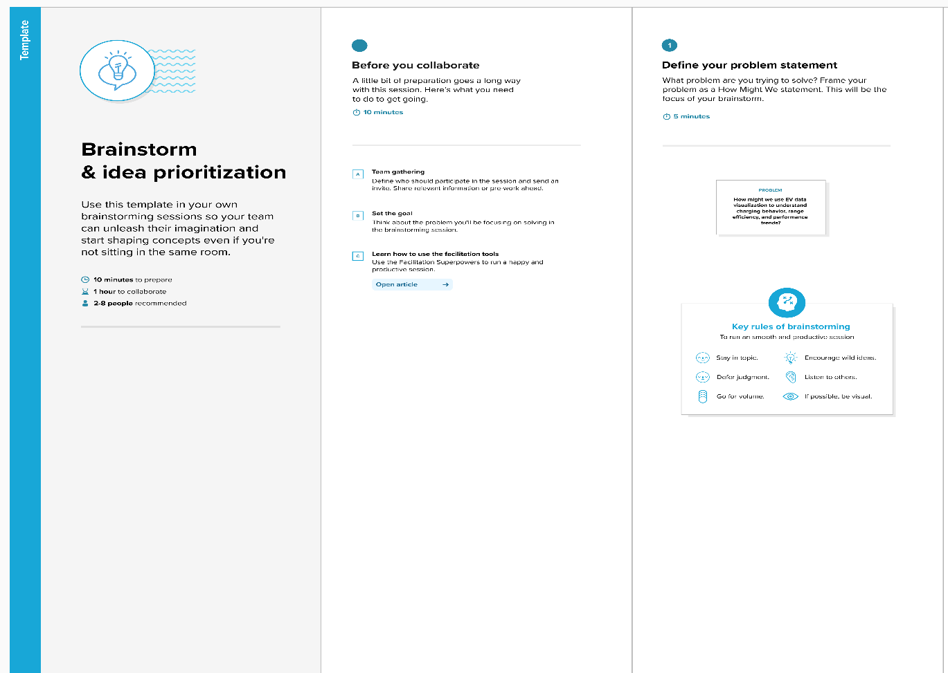

Step-2: Brainstorm, Idea Listing and Grouping
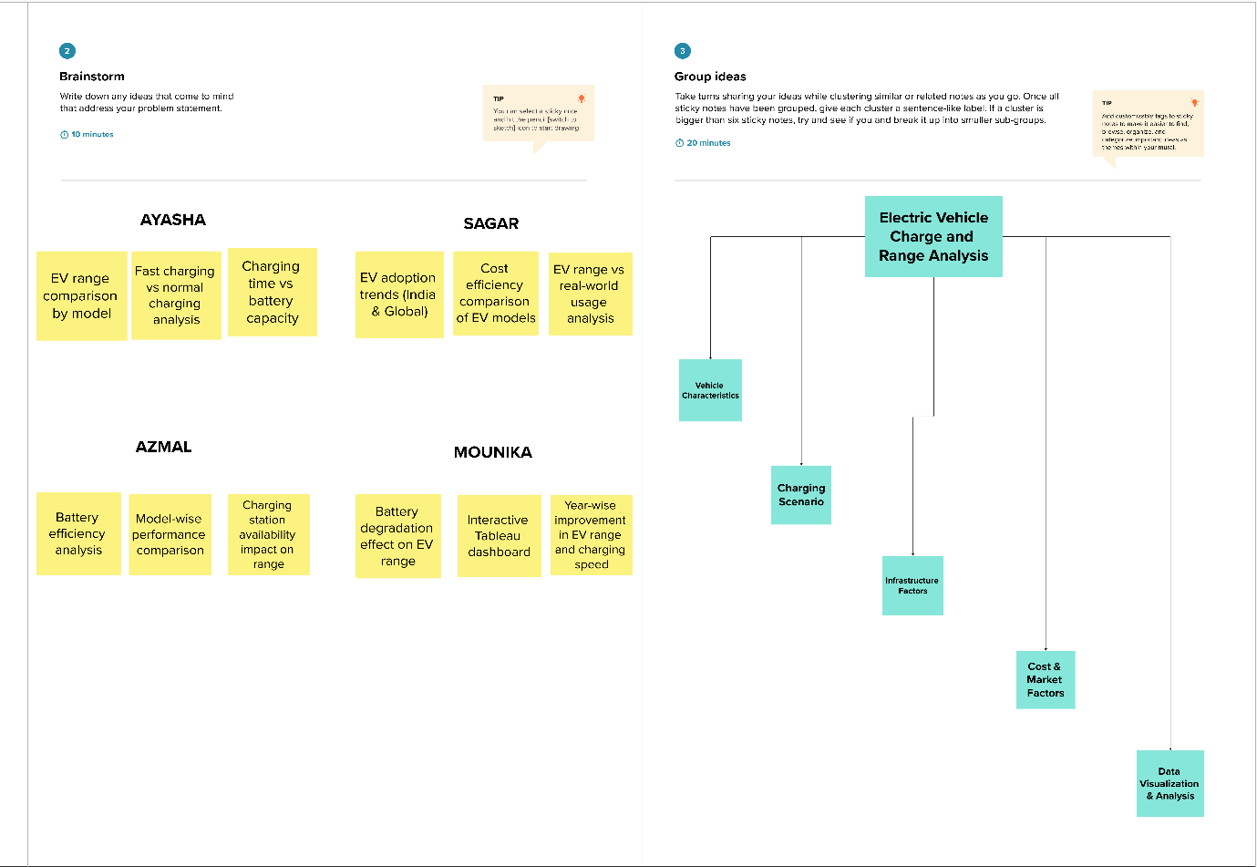

Step-3: Idea Prioritization
